
SUPERIOR UNIVERSITY GOLD
CAMPUS

- Name: Muhammad Abdullah
- Department: BS Artificial Intelligence
- Section: BSAI-3A
- Subject: AI (Lab)
- Submitted to: Sir Rasikh
- Roll no: SU92-BSAIM-F25-022

Lab Task 5
(Question 3)

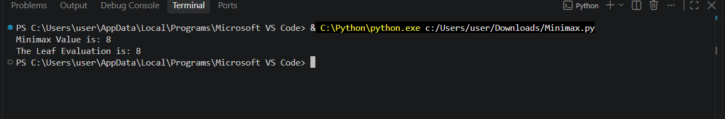
- Original Minimax Code Output :
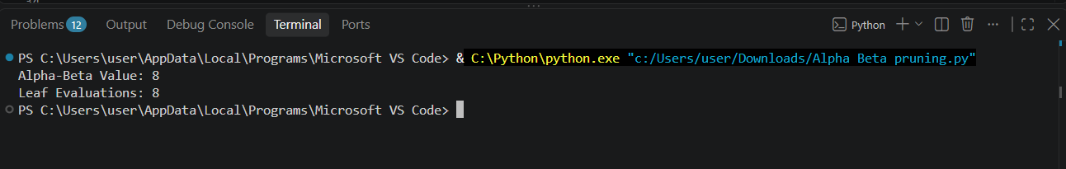
- Original Alpha-Beta Pruning Output:

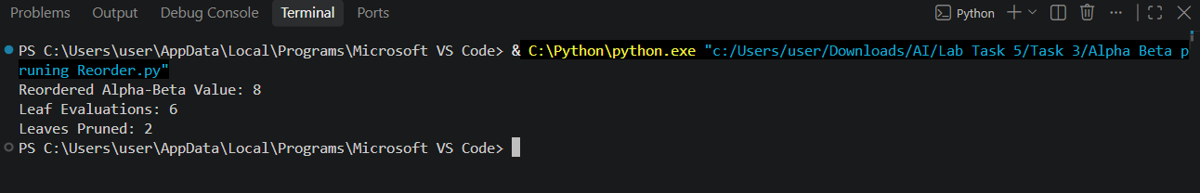
- Original Alpha-Beta Pruning Output:

Final Comparison:
Measurement | Original Order | Reordered Order
Minimax value | 8 | 8
Alpha Beta Value | 8 | 8
Alpha Beta Leaf Evalutions | 8 | 6
Leaves Pruned | 0 | 2
Reduction in Evalutions | 0% | 25%

In this case I change the order of branches
in the tree to observe the effect of alpha beta pruning on final root value.In the original case the algorithim visited the all 8 nodes but after reordering of branches only 6 nodes are visited while the other 2 nodes are pruned.Both cases return the same Minimax value which is 8.This prove the changing order of branches improves the efficiency of alpha beta pruning with no effect on result.

“ Documentation ”

I used the Same Alpha-Beta Pruning code as used in task 2.For counting Pruned leaves I Added a new function which counts all the leaf nodes before start of alpha beta pruning.Then subtract the number of visited nodes from the Total number of nodes to calculate the pruned Leaves value.In this case there are total 8 Nodes and the algorithm visit only 6 nodes then the remaining 2 leaves are pruned.

